**Part 2 – Commit a file to your repository**

Step 1 – Go to add file option.

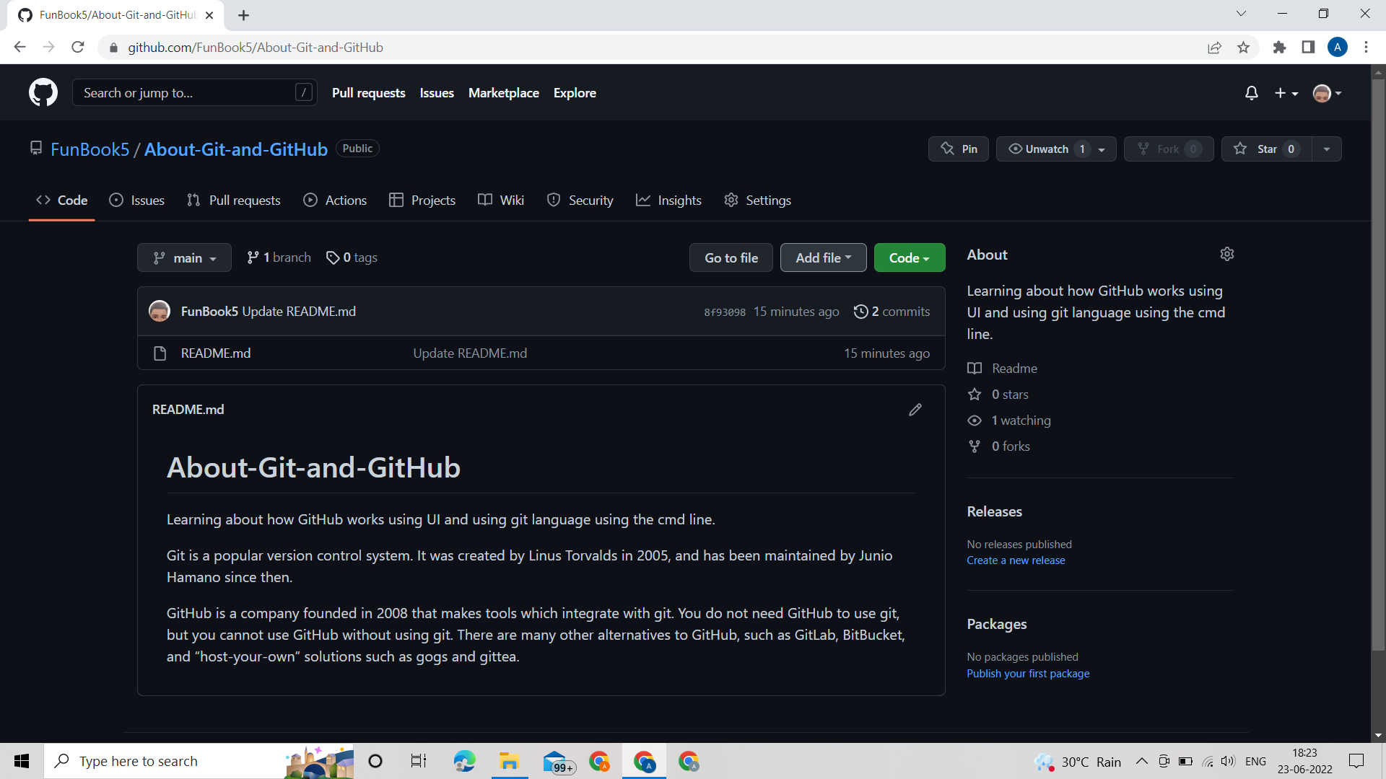

Step 2 – Click on upload files if you want to upload from the computer or new file if you want to start from scratch.

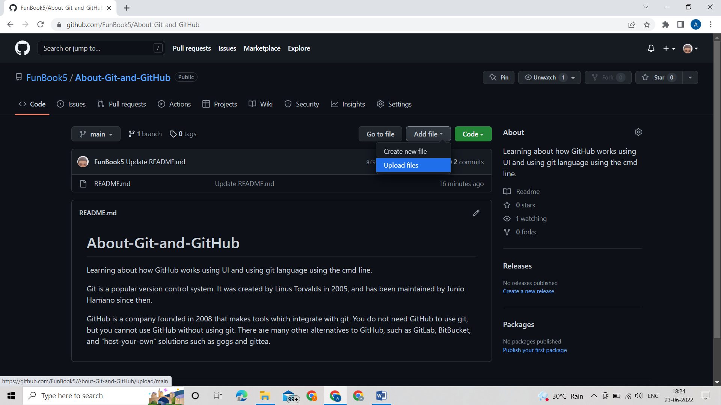

Step 3 – Select the files you want to upload using the choose the files option or drag the file using cursor

**If you want to upload the whole folder dragging is a better option.

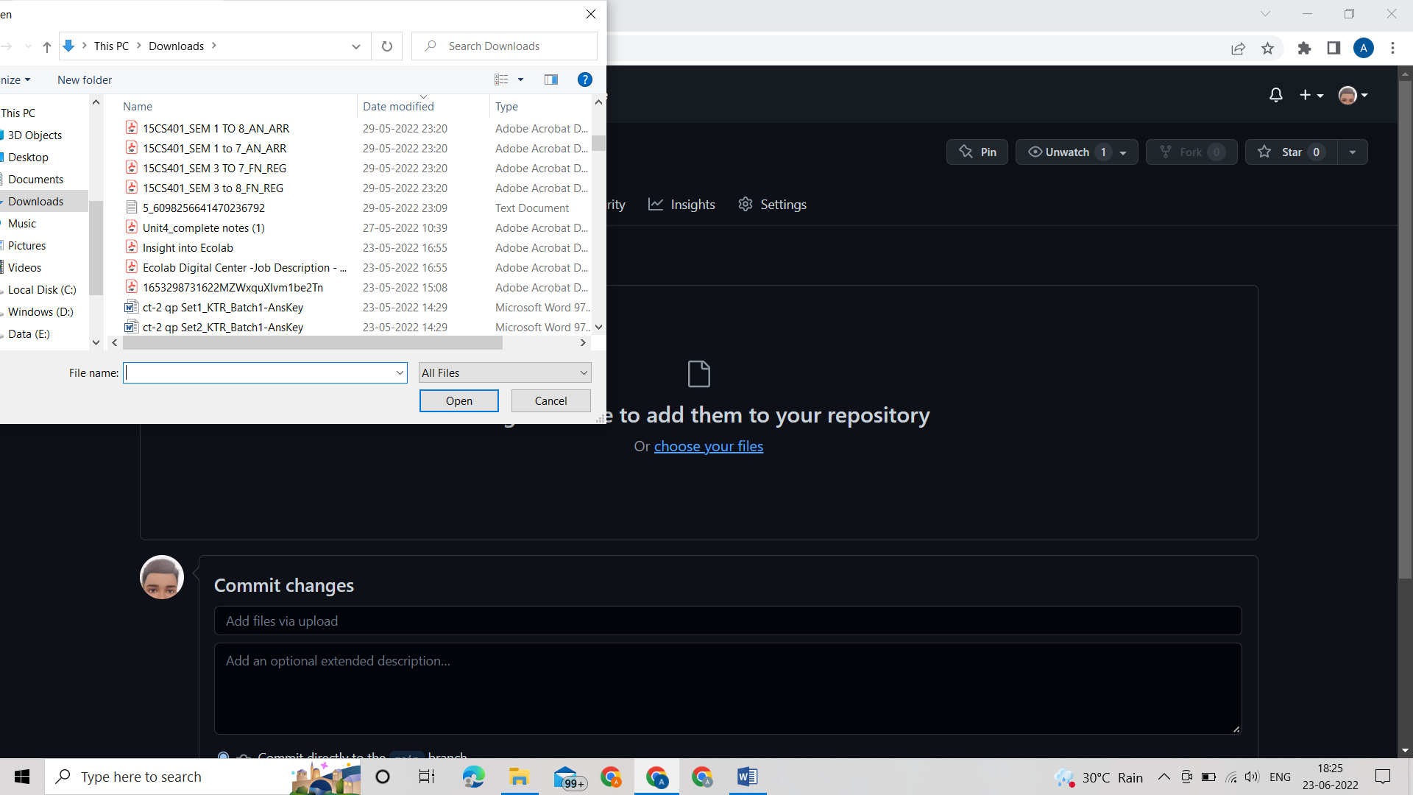

Step 4 – Verify that the right file is uploaded.

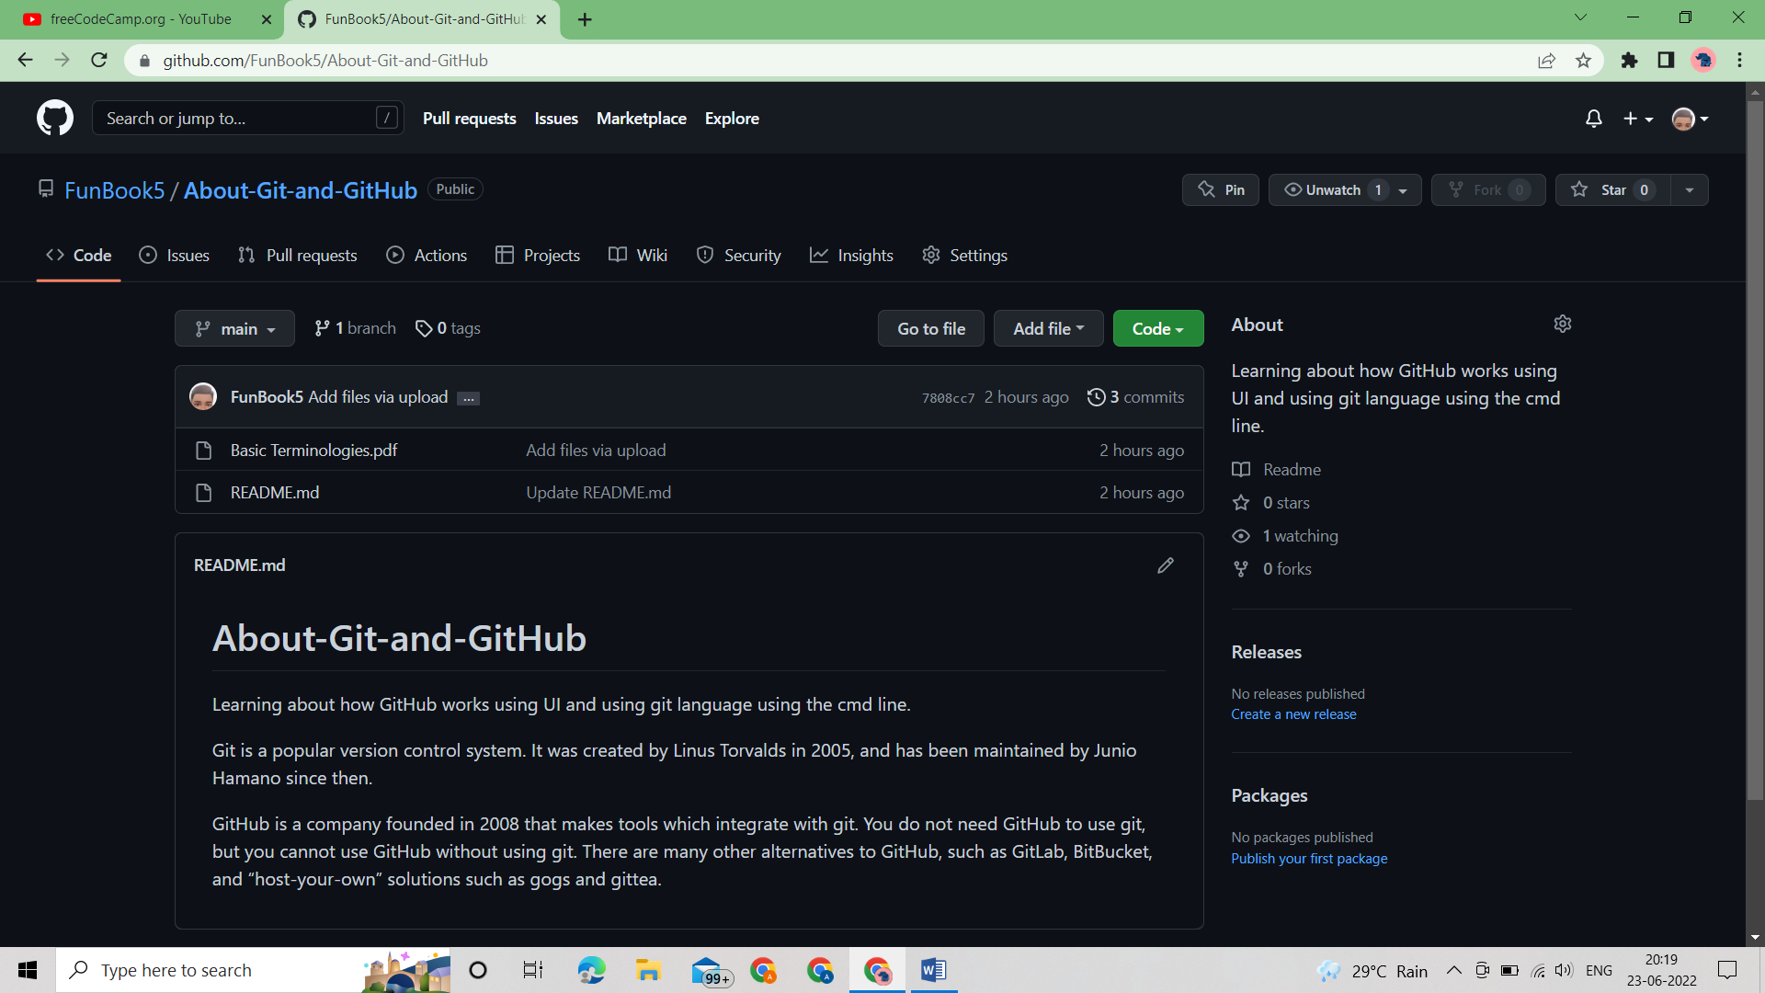

**There might be some change is the order if you upload multiple files therefore you can either use cmd line or upload files one by one.